Why covid-19 is impacting security environments differently

Summary:
- 79% of covid-19-linked security incidents in East and Central Africa from 1 March-7 May took place in Kenya, Malawi and Uganda. This post seeks to explain why this is the case.
- Our data reveals a strong correlation between the level of restrictions and the number of covid-19-related security incidents, but only when a country’s level of freedom is factored in. In countries where personal freedoms are minimal, covid-19 security incidents are also minimal, regardless of the extent of restrictions. In countries where personal freedoms are greater, we see increased security incidents correspond with increased restrictions.
- Most covid-19-related security incidents fall under two categories: 1) protests against restrictions, and 2) enforcement measures by the security services. Unlike countries outside the region, most obviously Chad and Mozambique, we see no correlation between covid-19 and changing patterns of armed conflict across the region.

In monitoring covid-19-linked security incidents across 13 countries in East and Central Africa, we see that 79% of the total number of such security incidents have occurred in Kenya, Malawi and Uganda. The remaining 10 countries have each witnessed five or fewer covid-19-related security incidents.

To understand this observation, we took two variables that could be expected to have a direct impact on the levels of covid-19-related security incidents: 1) the level of restrictions imposed by governments in order to halt the spread the spread of the virus, and 2) the level of freedom in each country.

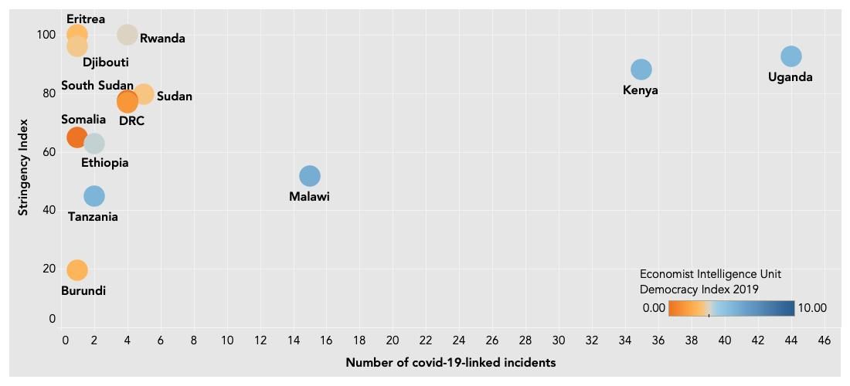
Taking data from the Oxford COVID-19 Government Response Tracker (OxCGRT)’s stringency index, combining with the number of covid-19-linked security incidents recorded by Standard Risk, and overlaid with ratings from the Economist Intelligence Unit’s Democracy Index 2019, we get the below chart:

X-Axis: Covid-19-linked security incidents (1 March-7 May 2020); Y-Axis: OxCGRT’s Stringency Index; Colour palette: EIU Democracy Index 2019.
Observations:
Levels of stringency – or restrictions – do not appear to directly correlate with increased violence. Eritrea and Djibouti have comparable levels of restrictions to Kenya and Uganda, and yet have far fewer incidents. When you factor in levels of freedom, however, a correlation becomes more observable. The three countries with the most incidents also score high on the EIU’s Democracy Index. Although correlation does not mean causality, the chart suggests that government-imposed restrictions can lead to increased security incidents but only where a certain level of freedom exists.

Digging into the types and dates of incidents recorded, several patterns are also observable. The vast majority (83%) of incidents in Malawi are linked to protests ahead of the expected imposition of a 21-day lockdown starting 18 April (the government’s decision was subsequently blocked by the High Court). Meanwhile, in Kenya and Uganda, most security incidents took place in the first two weeks after restrictions were imposed. It is perhaps not surprising that the evidence suggests that covid-19-linked security incidents are highest immediately before and after the imposition (or planned imposition) of restrictions. Restrictions represent shocks to the status quo, which heighten the likelihood of security incidents. Over time, however, as restrictions become the new normal and a new equilibrium is established, the likelihood of security incidents drops. This has been seen in both Kenya and Uganda where incidents peaked immediately after restrictions were imposed, then faded (although have not disappeared entirely).

Why does this matter?
If this assessment holds true, then we can argue that:
- Changes in government restrictions in non-authoritarian regimes tend to prompt an increase in security incidents. This works for the East and Central Africa region, and it may work elsewhere.
- For the region, Malawi will likely see a spike in incidents if the government re-attempts to impose or succeeds in imposing a lockdown. If Tanzania were to impose significant restrictions then it is likely that incidents will rapidly increase. Presuming the pandemic continues to negatively impact local economies, Ethiopia is particularly vulnerable to social unrest over time. Although classified as ‘not free’, it is closer to being ‘partly free’ than other countries in the category. With a recent history of heavy protests, Ethiopia is perhaps the country to watch most closely. For all three countries, the announcement and imposition of restrictions can be seen as destabilising factors, and accordingly could be considered as triggers for contingency planning. By contrast, restrictions in Burundi can likely be increased without resulting in a rise in security incidents, making new restrictions less applicable as a trigger for contingency planning.

Caveats:
The assessment is based off results from 13 countries; a small data set. Moreover, a multitude of factors influence the likelihood of the occurrence of security incidents, including precedents, norms and cultural factors. Over time, other factors may alter the results of this assessment. Economic hardship, for instance, is an all but inevitable consequence of the pandemic and this will likely further alter the existing security environment.
Additional research is required to determine whether the same observations and conclusions can be applied outside of the East and Central African region.

Data sources
The OxCGRT Stringency Index is out of 100, with 0 representing no changes in the operational environment and 100 representing full lockdown. Uganda and Rwanda score 93 and 100 respectively, indicating high levels of restrictions. Burundi scores 19, indicating that very limited steps have been taken. To note, Somalia and Eritrea are not covered under OxCGRT and so the scores are estimated by Standard Risk for these two countries, following OxCGRT methodology. The level of restrictions change over time, so in order to provide a fixed point for comparison the chart reflects the level of restrictions in place on 1 April.

The covid-19-linked security incidents are those incidents recorded by Standard Risk where, on balance, covid-19 was seen as the dominant factor causing the security incident. Health incidents
are not included (so someone contracting covid-19 isn’t considered an incident, although it may be considered as such for the patient’s employer). Rather, incidents tend to relate to protests against covid-19 restrictions, and government enforcement of these restrictions.

The Economist Intelligence Unit’s Democracy Index assesses states and territories across 60 indications. Scored 1-10, countries fall into one of four categories: full democracy; flawed democracy; hybrid regime; and authoritarian regime.

***
Standard Risk is registered in the UK and Kenya, and focused on supporting organisations make better security decisions through providing security information and analysis. The team is comprised of analysts, former humanitarian workers and security professionals, who are passionate about using data and analysis for better, safer decisions.

Standard Risk monitoring, for 1 March-7 May 2020
Blavatnik School of Government, University of Oxford. Data given for 1 April. https://www.bsg.ox.ac.uk/research/research-projects/coronavirus-government-response-tracker
Economist Intelligence Unit Democracy Index 2019: https://www.eiu.com/public/topical_report.aspx?campaignid=democracyindex2019

