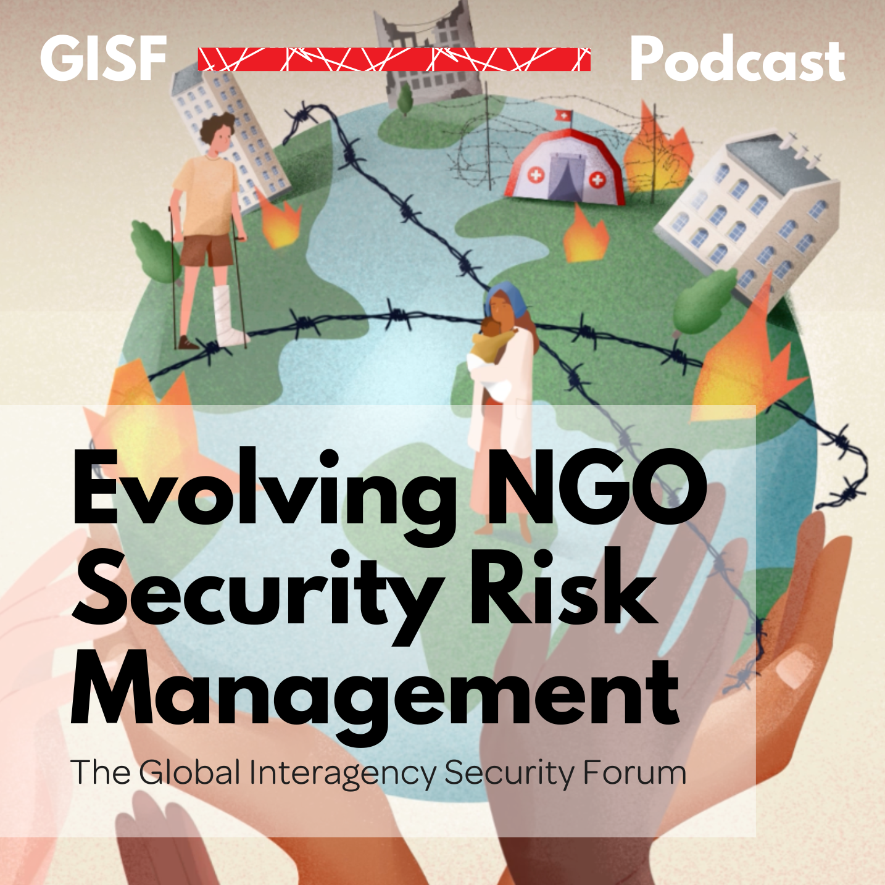

GISF Podcast Series

Evolving NGO Security Risk Management

Episode 2: 10 Years in Review: GISF and the evolutions of SRM

Total Time: 36:22
Speakers
Host: Tara Arthur (GISF)
Guest: Lisa Reilly (GISF)

Transcript

Podcast Series Intro:
In recent years, humanitarian responses have been complicated by compounding crises, such as climate change epidemics and pandemics and complex conflicts, and an ever-changing humanitarian and development space. We ask, what does the security and safety of aid workers look like? And what might it look like in the future? I'm Tara Arthur, from the global Interagency Security Forum. In each episode, I'll be speaking to guests about topics, such as the localization of aid, the ups and downs of community acceptance, and the role of security in a digital world. Join me as we unpack the evolutions of NGO security risk management.

Tara Arthur
Lisa Reilly, it's great to see you here today.

Lisa Reilly
Thank you. It's nice to be here.

Tara Arthur
Well, thank you for joining us. In today's episode, you know, we're gonna get into a little bit about you and look at the last 10 years. How's that sound?

Lisa Reilly
Terrifying. But yes, let's go ahead.

Tara Arthur
Oh, all right. Well, we'll try and make it less terrifying as we go along. How about that? Let's start with this one. You know, for those of you who might not be familiar, we'd love to hear a little bit more about who Lisa Reilly is. And maybe you can tell us a little bit about your current role and how you got involved in the sector.

Lisa Reilly
Okay, thank you, Tara. So I'm an engineer by training, and many years ago the first job I did was around constructing the Channel Tunnel, which sort of enables you to age me as to how long I've been working around. And then after working in engineering for a while in the UK, I felt I needed something more and something different. And my company actually gave me a two year sabbatical to do VSO voluntary services overseas. And I went to Namibia, as a water engineer, most of the stuff that I did, there was much more to do with community engagement than with actual engineering. And after two years, I found I didn't want to come back to the UK.

Particularly from a gender perspective, the opportunities as a woman in engineering was still prejudice around, there were jobs that I'd applied for, where I was extremely qualified for them. But the only reason I didn't get the job was because I was a woman. And that became apparent to me. So, there were actually far more interesting opportunities available within the development sector sphere, as it was at that time where I was working in Namibia. So, I stayed on in Namibia for another three years, before I decided I wanted to do something different. And it was at that point that I actually moved more into the humanitarian space. My first job as a humanitarian response worker, again, engineering was in Sudan, when it was still one country. And I worked in various humanitarian jobs for the next eight years or so. So from Sudan, I went to Afghansitan And I was there sort of 2000 to 2003. I was back in Afghanistan around sort of 2009 and 10. So that was very interesting to see how much it's changed. And looking at what's happening now. It's very heartfelt for me, as I think back to my colleagues, and how they must be faring at the moment. I worked in Aceh in the tsunami response and down in Mindanao, in the Philippines.

From a security perspective, when I was working in these humanitarian responses, security was generally still the responsibility within the programme management line. So as programme manager as Country Director, I had that responsibility. And while in my last posting, before I came back to the UK, I did have an ex Pakistani military who was part time security adviser who was very helpful and very useful. It was still decisions around security and what we could and couldn't do and how we manage the risks was very much within the management function rather than as a separate security function. So I did that and I was overseas for I think just over 13 years in total.

I came back to the UK basically because I was completely burnt out. I had one worked myself to a standstill, which explains some of what I'm now doing as my future and what's going forward. And I needed a change. When I originally came back to the UK, I didn't think I would stay, I was very surprised that I'm actually still sitting in the UK. What made me stay was the job opportunity I found and I was sitting there, you know, thinking, what is it that I can possibly do? After all of these years working overseas, and RedR were advertising for a security trainer. I thought, well, I've never been trained as a trainer, I've never had a security job, let me go and apply for this job as security trainer, and I got it. I loved it, I found I thought it was an opportunity to be able to share what I had learnt. So rather than just having this huge accumulation of knowledge, just disappear into a black hole, I had the opportunity to be able to use my experiences my pain to hopefully help, you know, some of the next generation of aid workers to not have to go through the same level of pain. It was something that gave me satisfaction. And to actually unpack security, as a, as a function in itself, rather than just part of what had been doing as a country manager was really interesting. And the more I understood about it, the more I wanted to understand, and I'd never heard of the security strategies, the acceptance, protection deterrence. So when they were explained to me, I thought, Oh, well, that's what I did. And I remember in Afghanistan, when I was there, the first time around, we had our offices in Mazār-i-Sharīf. But we weren't actually implementing any programmes there. So the community around where we lived, didn't necessarily know who we were, except for the fact that we had a noisy generator, and lots of cars that occasionally blocked to the streets. So we talked to the local community, and there was a school that was sort of within the block where our compound was. And they had a well, but all they had was one tap, they didn't have a proper washing station or anything. We thought we would put in latrines and hand wash station in the school, so that they knew what we were. So that's what it is about and acceptance strategy. So it was interesting to discover that there was a lot that I'd been doing from common sense, which actually fitted into what we should do when we look at what what's good security risk management practices.

Tara Arthur
So is that what you're still doing today working in the security risk management space?

Lisa Reilly
I suppose. So you could say that. So after leaving radar, I joined ei SF as it was then the European Interagency Security Forum. As the director, at the time I joined, we had a team of three people, three people in an intern, I think it was. So over the last 10 years, we've grown from, you know, four people and 40 members, to about 145 members and a team of 13 people. We've gone from being European base to global. So it has been an exciting 10 years.

Tara Arthur
Wow. There's a lot to be proud of, in what you've shared. It sounds like and a lot to unpack further in our conversation. I want to take you back a little bit and ask you, you know, when you first got into the sector, did you have any expectations for what you might accomplish?

Lisa Reilly
My honest answer to that is, it's probably no, but always. But it's interesting. I've not thought about that before, but I think I felt quite strongly. I was coming at the topic of security from very much a humanitarian perspective. I had no formal security training. But I knew the realities of trying to keep staff safe in these high risk and conflict areas. And I had some quite troubling experiences when I was in the field level. Have some of the security people I met the early security professionals who joined the NGO sector, ex military, no respect for the NGO community security should be something that is driven by the humanitarian need the humanitarian programme. And that should be the purpose of it, not the need just to we can keep people safe by locking them in a room and putting sandbags all the way around it, but it doesn't help us implement our humanitarian programmes.

So really try I suppose that was what I thought I could bring to it is that pragmatic approach of linking security into the humanitarian sector, and the fact I suppose from the other way around, is trying also to raise awareness amongst humanitarians, that security is not an add on. It has to be integrated. I mean, one of the things as I say, I started as a, as a water engineer. And one of the things that used to happen, would somebody would come along, one of the team would come along and go, Okay, we found this super spot for a school, it's on the top of the hill, it's a great advantage place, can you now come and give us a well? And I'd go, No, we can't, you've picked a spot that's nowhere near any water, and you've chosen the top of the hill. So we've got you, you're too far above the water table for us to actually access the water with a hand dug well, anyway. So I see security as a similar thing as you as you can, you know, think of an integral part of the programme and think about it after you've done three quarters of the design and construction has to be something that's there. Right as you start the programme.

Tara Arthur
I think it's interesting what you are saying about the way you've brought new perspectives into security? And I think, you know, it'd be interesting if we take a moment to look even a little bit broader at your time. And what changes do you think have been made in the sector over the last 10 years, in particular, and maybe a little bit also on where we might need to go? And where do we need to continue to proceed forward?

Lisa Reilly
I've definitely seen set changes in the sector. How much influence I've had on those, I don't think they're my strides. I think there are other people's CISF representatives within the organisations are those people who have responsibility for a global level for the safety and security of humanitarian staff travelling overseas. Some are directors, some of the P summer managers, summer advisors, so it's difficult to sort of say, you know, from a job title, but the people who who come to our meetings and who engage are those who have primary responsibility for security risk management, amongst the 40 people, 40 organisations, when I first started, while about a third of those members were women, which has remained fairly constant.

What has changed is the number of people who come in from a traditional security background. So people who have come in who have come from the military who come from the police, that proportion has reduced. I mean, they brought in so many skills, and they continue to bring in skills and knowledge which is so important. But the recognition within organisations that they may be need to look for something above and beyond that is great. But also, you know, some of the people who have come in from with a military background, to me that makes them humanitarian. So it sounds

Tara Arthur
like you've seen some some good strides there are there are broader things that you would like to see the sector kind of build on from that foundation of evolving from, you know, kind of the, if we can call it traditional military and police backgrounds to broadening these profiles of the different security managers, but what do you think are some of the ways that foundation is growing?

Lisa Reilly
So while you know the proportion of women has remained quite constant to third, there still needs to be more women. There needs to be also a much greater racial mix. If we look at our membership, almost entirely white. With a few exceptions, we're seeing A few more regional people moving up to those global positions, but is still predominantly white. And the culture is still male. So even though we've got the women involved, it is still, you know, driven by this historical perspective. But one of the problems is is, we have made a lot of changes. And if you look at the way the sector works, now, the security component works, it is very different.

But unfortunately, a lot of humanitarians, who, particularly those in the senior positions, remember what we used to be, as the security people quite risk averse, rather than enabling. And so breaking the silo the other way. And I think a lot of the time, while we have made these changes, in our approach, you know, it's not about hard security, it's not about sort of gates and convoys. It is about risk management. It is about enabling programmes, it's about you know, working for good access, sustainable access. It's about engaging with all of the staff and trying to take this sort of person centred approach. The problem is, if the rest of the humanitarian sector still see us, in that idea of, you know, the white ex military, they still excluding us from the conversations, I think this to me is where I think we still need to see the most change is the breaking down of the silos. And recognising that security risk management has to be cross cutting, we're seeing quite a lot of the work in the sector at the moment around sort of advocacy and policy, and the protection of aid workers. But a lot of the time this conversation is being held by policy people. And they're not necessarily aware of all the stuff that's going on at the ground level that we've been working on for years, to try and do this. Now the thing, one of the problems, and one of the reasons for that is people who go into Security, don't tend to be the people who want to stand up and do advocacy. So we don't have the voice. We're not projecting our needs and our voice out there. So we need the advocacy people, but they need to understand us. So we need to find a way to bridge the various, you know, silos, between security and advocacy between security and programme, security and HR. We need to recognise that we're all working for towards the same aim.

Tara Arthur
And just from that, do you feel like there's something in this moment that we're currently in, that you would want to, you know, help break that silo down further, is there something that you think is in this moment that you would want to share or maybe leave as a legacy note of your experience, having helped bridge the gaps from previous moments like this in the sector? Reflections forward,

Lisa Reilly
I'm a bit worried about the idea of legacy, because I don't think this is me, I think that, you know, this is a moment in time that myself and GIS F have maybe had some input into but it's a sector change, this isn't isn't my legacy, maybe others will disagree, the legacy of please. So, I think two of the projects that we've worked on in the GIS F and the sector over the last few years, the first one was around the paper we did was security risk management staff with diverse profiles. And that was so interesting, when we started it, the number of people who came to us and went, why are you doing this? This isn't needed. And it took us many years because we started with the gender and security paper, and then we moved on to that one. And the sea change in the sector, as we push through that process, and there's discussions and and what's happened since. And, you know, just part of the broader being there as part of the broader discussion on inclusion, diversity and equity. And being able to be an active part of that conversation, not a bystander going well, what do we do about it? But actually, they're going well, this is what we do about it and this idea of, you know, a person centred approach to security risk management. And I remember talking to somebody who went, why are you talking about a person centred approach? Of course, it's a person centred approach, how can we do security if it's not a person centred approach, which is absolutely true. So it's also quite sad that we are having to talk about a person centred approach to security risk management, because unfortunately, a lot of what was done in the past wasn't. And again, an interesting conversation I had with somebody recently, and, and they were sort of saying, you know, they had staff members who very caring who were going, you know, I will never ask somebody to do something that I'm not comfortable doing. Which sounds great. But if you're a 50 year old white man, what you're comfortable doing is going to be very different to what a 30 year old black woman may be comfortable doing. So it's, you know, these conversations around unconscious bias, and recognition, I find really uplifting and an opportunity. And I think there is a big question about how do we go from theory to practice, organisations are chipping away at this. But I think that, to me, is a really great change, and an opportunity to keep going, and to push that and, and in many ways, it links with the localization agenda. And also, I mean, the research piece we did, and the subsequent Guide, which really takes the partners perspective, and gives us an evidence base for not only really trying to shift the conversation to risk sharing from risk transfer, but also to be able to go, Look, you've got to give resources to national organisations to be able to manage their own security. And that feedback that national organisations are worried about raising security concerns with their international partners, because they think they won't get funded. But in a way, why are we surprised because as I NGOs, we don't raise the fact that we've got security concerns to our institutional donors, because we're scared we won't get funding. Now, maybe we don't put it in those words. But if you look at the lack of resources for effective security, risk management, and often, you know, the minimal donor engagement on this, yeah, we can see it goes and I bet it goes between the national and the community based organisations. But there's a similar concern.

Tara Arthur
Wow, there's a lot there. And I think it's really wonderful to have your, your thoughts on this, because you have seen the sector over the last few years and the changes that are, are happening and need to continue to, to take place. And you brought in some really interesting practical elements about your time at JSF. And this one, I take you back there and maybe go a little deeper as to what has been at JSF, meant to you.

Lisa Reilly
It's been an amazing experience, the longest I've ever held a job before I came to JSF was three years. So the fact that I've been here for more than 10, I think is a really good example of what it's meant to me, from a personal perspective, the conversations, the people I've met, the stuff that I've learned, is unbelievable. But I hope the reward aspect of what I do is I hope that we've made a difference that we've facilitated a, a change that people know where they can come for resources. And if we look at what's available, the fact that we've now got, you know, 100 more organisations than we had. And we haven't marketed this is word of mouth. This is people coming to us saying, Can we join as well. And the fact that, you know, we started out very much humanitarian with a few development and we've now got human rights based organisations, some peacebuilding organisations, and they're coming to us and saying, We want to be part of this, we want to keep our staff safe. That is hugely rewarding for me. And I think the final piece that I'd like to mention is my team and this After I've been able to work with over the years, and one of the sad bits of being such a small team is that there isn't a lot of progression. So while I've been here for 10 years, there's been a lot of turnover of staff. But I look at the jobs that they've been able to go on to. And I feel that, you know, even people who've interned for us have all gone on to get really good jobs, and have all appreciated their time at GE ISR. And I think that's the other thing for me, which makes me proud. And about cry, is how much the team does mean to me, I suppose actually, before I go, otherwise, I'll get into trouble. I want to also mention the members. And it has been, there are some amazing people amongst the members again, you know, saying about the people I've met the conversations I've had the willingness of our members, some of our members to really share their resources, their experiences, we've talked a lot about you know, the only time you learn is when you make a mistake. But through our members, we've been able to learn from other people's mistakes, because our members are willing to share to a level because it's a safe environment is really heartening and provides that opportunity for cross learning between organisations. So I think our members is also something that's really kept me engaged and interested in this role.

Tara Arthur
It has been an amazing period to have you here at USF. And I can probably speak for many who appreciate the contributions you have made and continue to make and will continue to make in different ways. So let's go there a little bit. What is ahead for you? What are the opportunities coming your way,

Lisa Reilly
some time off, perhaps might be the first first luxury item, hopefully exciting new opportunities. I mentioned briefly, the state I was in when I finished my last mission in Pakistan and I basically had PTSD. But it was from a buildup of stress and some sort of serious incidents, but not one sort of serious incident. So sort of complex trauma is how it's sort of described now with everything else that's going on in my head. So I started my therapy journey, which I have been on ever since. And about five years ago, six years ago, I actually started training to become a psychotherapist, just because I found it absolutely fascinating. And I hope that you know what I've learned, as my training has gone on in psychotherapy. I'm also applying to the day job and GIS F and security. And certainly along with many other people within the sector, the idea of mental as well as physical safety is something that is fundamental to good security risk management. So I brought in, you know, a lot of that learnings from my psychotherapy training. And I know a lot of people who I talked to who are still sort of working at country level, or even at headquarters level, they try and talk to a counsellor. And unfortunately, the counsellor doesn't actually understand the context. So it can be quite difficult to find the right person who has that experience. So I'm hoping that my experience will enable me to be a good therapist, for people in the humanitarian sector and others as well. So that's part of what I'll be doing is continuing to expand my my psychotherapy practice. And I think just building on that, so not only the psychotherapy practice, an area that I am really interested and hope that I can continue to do more more work on is this whole idea of mental well being and safety and linking that up with a good security practice. So I do want to stay in the sector not only as a therapist, but also looking at, you know, where can we go to make the sector as a whole, healthier and safer all those who who give their time and energy to meeting humanitarian needs.

Tara Arthur
Why I think many will be happy to know that Lisa rally isn't going away too far. But we'll be making new contributions in exciting ways that I think will add a lot of value to what we're all trying to achieve together. So that's really, really nice to hear, Lisa, just, you know, thinking about all of today's conversations, and the many that you've had on this journey. And I just want to give you a moment to share any reflections you might have, as just as outgoing Executive Director, as a woman in the sector as we survived Lee, as however you feel you want to leave some words of wisdom with us today,

Lisa Reilly
words of wisdom. Gosh, if only I had some so many reflections, I think security risk management is fascinating. It's challenging. It's complex. But if it's done well, it makes a huge difference. And I think that, to me, is what's kept me engaged, is knowing that, you know, if we do what we need to do, well, it has a huge impact. And if you can do that, and at the same time, meet amazing people and continue to learn. If we stop learning, I It's a very sad state, I think if certainly never going to say I know everything ever, always learning from different people. And one of the things that I do do is I sort of guest lecture that a couple of universities and the questions they ask the students ask the next generation of humanitarians gives me great hope for the future.

Tara Arthur
Well, that's really wonderful, Lisa, and glad that you're also helping to bring in the next generation through your work as well. So is there a memory, or it's a moment or highlight that made you most proud about the work you're doing?

Lisa Reilly
It's difficult to pinpoint one memory, I can think some of the forums that we've attended and the feedback from members, I'd say those are the things that have made me proud is when members or other people we work with have come to me and said, Oh, we've just done this. And we wouldn't have been able to do it without the jlsf documentation, we've been able to get through this crisis because of what we got through being part of GE ISR. And then on a personal level, you know, there are a few students who I've talked to her now members of GE ISF. And people who were sort of national staff who I met during my travels, who have moved up through their organisations and again, now in more senior positions, who've said that, you know, what I've, what I shared with them, and how I worked with them has have helped them on that journey. So I'd say they, they're the memories that might be proud. I suppose the other thing that I shouldn't be proud of, and I should remember to mention is that in 2020, I won the women insecurity award from the professional security magazine in the UK, for contribution to the industry, which I think was quite a good recognition. Again, as all of these stories go with me happened during COVID. So we weren't able to go to the formal or the formal sort of presentation, dinner was cancelled. So I was sent a care package, which included quite a lot of wine, some very nice snacks, and some giant party popper type things to celebrate. So when I won and I had a couple of colleagues around for the evening and COVID rules, and we celebrated and one of my colleagues left off one of these giant party poppers that was full of centimetre gold discs. I'm still clearing mark now. Every so often I find them around my house and it reminds me of that amazing evening, not so much because of the award that I won, but the colleagues and the friends that I had around me.

Tara Arthur
Wow. Well we hope that you find many disk for perpetuity to come. We love you keep finding them because that is a really really nice memory you shared with us. It's been an An absolute honour and what a privilege to be able to learn from you personally, if I can say that, and have this opportunity to speak with you about your journey. And it's just really exciting to know that you won't be too far. But we're all still very grateful for the many contributions you've made along the way. So thanks for being with us today. And thanks for helping us to understand a little bit of your insights over the last 10 years.

Lisa Reilly
Thank you very much. Thank you, Tara. Thank you to the GISF Secretariat, past and present, and to all our members and all of the other amazing people I've got to meet over the last 10 years.

Podcast Series Outro:
The global inter agency Security Forum is a member led NGO with a global network of over 140 member organisations and affiliates. We are committed to achieving sustainable access for populations in need, through improved safety and security for aid workers and operations. GIS F's original research, collaboration and events drive positive change in security risk management across the humanitarian and development sector. We operate according to humanitarian principles and lead on best practices and innovation by pushing for a collaborative and inclusive approach to security risk management.

