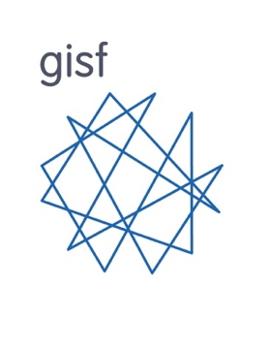
Tool 4: SWOT Analysis template

STRENGTHS | WEAKNESSES
What do we do well within our current SRM framework/approach? What internal resources or capacities do we have/can we tap into?  e.g. a good culture around SRM, experienced SRM staff, robust risk assessment tools, strong learning and development programme. | What areas of our current SRM framework need improvement? What resources or training do we lack?  e.g. inadequate training on crisis management, lack of understanding and engagement with SRM, outdated technology, poor infrastructure.
OPPORTUNITIES | THREATS
What opportunities exist that SRM could tap into or benefit from? Are there places where SRM could help achieve whole organisation objectives/meet strategic goals?  e.g. emerging technologies, new partnerships and networking opportunities. | What might threaten our effectiveness in implementing SRM across the organisation?  e.g. staff retention, cybersecurity breaches, areas of operation in high-risk contexts, staff burnout.

