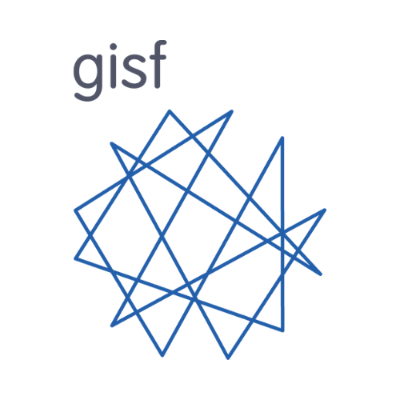

GISF Member Steering Group
Agreed by Board: February 2025
Revised May 2025
Agreed by Board: July 2025
Revised January 2026

Purpose

The Member Steering Group (the SG) is a formal sub-committee of GISF’s Board of Directors. The Board has overall responsibility for the organisation meeting its statutory, fiduciary, and other obligations- including ensuring that GISF’s activities meet the needs of their INGO membership in line with GISF’s governing documents.

The SG supports the Board by:
- Using delegated powers to approve or decline membership applications in line with established criteria.
- Suggesting amendments to membership criteria.
- Reporting on GISF’s performance with regards to serving its members.
- Providing members’ perspectives on key decisions when requested; and
- Identifying the thematic priorities of members to inform GISF’s annual workplan.
- Supports the board and secretariat on strategy

Composition

A group of no more than 11 individuals (‘Steering Group Representatives’) will comprise the Member Steering Group. A Member Representative's organisation must be ‘financial’ (I.e. up to date on membership fees) to sit on the SG. If a Steering Group Representative leaves their member organisation, they will vacate their seat on the SG.

One Steering Group Representative has an automatic seat (and is not elected by the members):
- Americas Steering Committee Chair.

Up to two (2) Steering Group Representatives can be co-opted for a two-year term. They cannot be co-opted for a second term. This requires a nomination by an existing SG Representative, and a simple majority vote by the full Steering Group.

Two Steering Group Representatives are voted by the Steering Group, on a simple majority (50%+1) to fill the following roles:
- SG Representative to the Board of Directors (two-year term) (see below).
- SG Representative to support SLT initiatives (two-year term).

Elections to the SG from the Membership will be via a well-publicised, transparent process. Vacancies will be advertised in such a way as to encourage representation that is proportional and representative of Members’ operational sectors and size (e.g. humanitarian, health, human rights, etc.).

Once elected, Steering Group Representatives will sit on the SG for a two-year term. At the completion of two years, Steering Group Representatives may seek nomination and be voted in for a subsequent term. There is a limit of two consecutive terms.

Steering Group Representatives are not remunerated.

Elections

- When vacancies arise, the SG will conduct an audit of current Steering Group Representatives to identify where gaps in representation exist. A decision will be made by the SG to co-opt to cover specific gaps or to have an election. Co-option may also take place if an election has been held recently, to avoid election fatigue. Gaps will be noted when the vacancy is advertised to Members, highlighting that applications are particularly encouraged from relevant members.
- Elections will be held at a minimum every two years, to cover the rotation of SG members elected on two-year terms.
- Applicants will apply with a 200-word statement of what value they will bring to the SG, and what they will hope to achieve. They will also describe how they have engaged in GISF-related activities.
  - If necessary, current SG Representatives will be asked to confirm that sufficient engagement has been demonstrated. GISF Secretariat can provide further details on recorded engagement.
- The application must be accompanied by two signed nominations from other GISF Members.
- Statements from prospective Steering Group Representatives will be shared with the membership (regardless of whether there’s a requirement for a vote).
- If the number of applicants exceeds available spaces, provision will be made for members to electronically vote for their preferred Steering Group Representative.
  - Members have one vote per organisation, through the GISF primary contact
  - If the number of applicants is equal to or less than the number of available seats, a confirmatory vote will be offered to members. Members will vote on the proposed SG representatives as a group (i.e. not on individual candidates) with the options of Yes/No/Abstain. Yes>No allows the appointment to progress.

In exceptional circumstances, and by a simple majority agreement of the Steering Group, the usual election process and terms of office may be varied, if considered necessary or appropriate.

Operation

The SG meets four times per year. At least one meeting per year is held in-person, alongside the Annual General Meeting. This will typically occur in Western Europe or North America. The remaining SG meetings being hybrid over the course of a calendar year, Steering Group Representatives are expected to attend at least three out of the four meetings. SG meetings aim to be scheduled in advance of the Board’s quarterly meetings, to enable issues to be raised.

Seven representatives are required to form a quorum.

The GISF secretariate provides support to the SG in organising meetings, providing data on GISF’s performance for evaluation, and in collecting member insights on thematic priorities.

Membership applications requiring approval will be distributed to the SG on a quarterly basis. Decisions require a simple majority (50%+1).

Minutes of meetings must be taken to capture key discussions and decisions and should be submitted within one week to the Executive Director and the Board Chair, for sharing with the board and action by the Secretariat (for example, on membership approvals). GISF will provide secretariate support for minutes.

A Chair and Deputy Chair of the SG will be elected by Steering Group Representatives to run meetings. The election requires a simple majority (50%+1).

A seat on the Board of Directors is reserved for a representative of the SG; Steering Group Representatives can volunteer for this position. If more than one Steering Group Representatives has volunteered, one will be elected by a simple majority (50%+1). The Representative must be able to commit to the requirements of all other Non-Executive Directors in terms of attendance and should be able to commit to the role for at least 12 months.

The Steering Group Representative on the Board of Directors will be legally registered as a Non-Executive Director with Companies House in the United Kingdom - the person must not be disqualified from being a Director. The Representative, as a Director, will be legally responsible for GISF CIC.

If the SG is unable to appoint a Representative to the Board, or the seat is vacant for more than six months, the Board reserves the right to appoint a suitably qualified individual employed by a GISF CIC member until such time as a Steering Group Representative to the Board is elected by the SG.

Accountability

The SG are accountable to both the Board and the Membership.

Steering Group Representatives

Main Responsibilities

- To interpret membership criteria and vote on new applications for membership to GISF
- To promote the work of and encourage interest in GISF through their networks
- To foster a positive culture within GISF, including engaging with new attendees at GISF events
- To use their networks to support the GISF Secretariat in identifying speakers, partners, contributors, etc.
- To actively engage with the full range of GISF members to gather perspectives and to feed this into SG discussions and to the Board
- To assess the performance of GISF and report on it to the Board and the Membership
- To work with the Secretariat to develop and implement processes to identify thematic SRM priorities within the membership that can shape GISF activities
- Support the Board and Secretariat on GISF strategy development.

Desired Experience

- Demonstrated period of engagement with GISF activities
- Experience in SRM at a senior level within an NGO

This is to ensure proportional representation of member organisations (see following paragraph)
i.e. having served two terms and ceased being on the SG, an individual representing a member organisation may seek nomination at the next opportunity.

